Prospero’s House
An example of a blueprint of a house…

In Act IV Scene 1, Prospero mentions his house:

This was well done, my bird.
Thy shape invisible retain thou still.
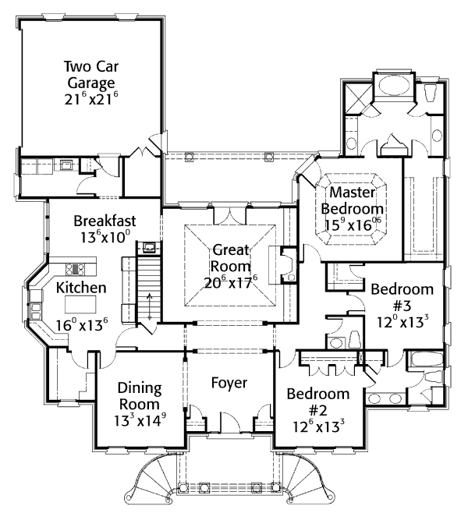
The trumpery in my house, go bring it hither
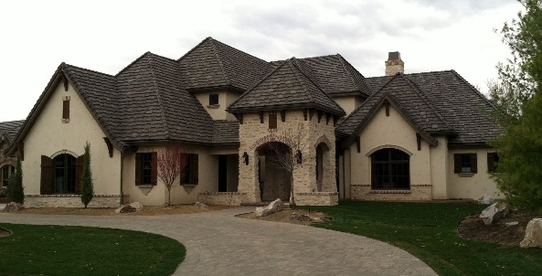
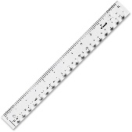
For stale to catch these thieves
You will be given an A3 piece of paper. Turn the paper to a landscape orientation.
Ensure you use a ruler and a pencil. Use the pencil lightly so that any errors can be rectified.
Draw a blueprint of the rooms on the ground floor of Prospero’s house.
You should read all of the instructions before starting and then go through them one by one.
All rooms are square or rectangular in shape.
- Draw a dining room in the middle of the of the palace. The width of the room on the blueprint should be 8cm and the length 11cm.
- Draw a large kitchen to the right-hand side of the dining room. It should have the same area as the dining room but a different perimeter.
- To the left of the dining room, draw a bathroom. The perimeter of the bathroom is 6cm by 9cm.
- Under the bathroom, draw a cloakroom that is 4cm by 6cm.
- Above the kitchen should be a wizard’s room. The wizard’s room has the same area as the bathroom but a different perimeter.
- Under the dining room should be a main entrance. The perimeter of the entrance way is 12cm by 3cm. The rectangle should be portrait orientation.
- On either side of the rectangle should be two drawing rooms, both have an area of 28cm² but the perimeters are different.

Challenge Task 1: Now compare your blueprint with a partner. Is it the same or different? Discuss any differences.
Challenge Task 2: With a partner, on a separate piece of A3 paper, design your dream house. You must try and create rooms that have the same area but different perimeters.

