The Capulet Property

In Act 2, Scene 1, Romeo is still at the Capulet property. Help measure the perimeter of the different rooms so it’s easier for Romeo to find his way around when dark...

For each room, the area is given, write 2 possible perimeters that the room could have.

1. The Capulet hallway
2. Juliet’s bedroom

[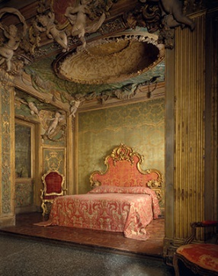](https://www.google.co.uk/url?sa=i&rct=j&q=&esrc=s&source=images&cd=&cad=rja&uact=8&ved=0ahUKEwi27o6PhsjYAhVaOMAKHfzGAcUQjRwIBw&url=https://www.metmuseum.org/toah/ht/09/eustn.html&psig=AOvVaw3ha8JuhB9Ps6ij3Tsb3ter&ust=1515489939824480)

**[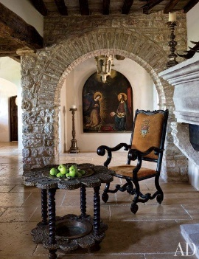](http://www.architecturaldigest.com/decor/2013-11/martyn-lawrence-bullard-evgeny-lebedev-domenico-minchilli-umbria-italy-castle-slideshow_slideshow_After--Dining-Room_12)**

16m 2

12m 2

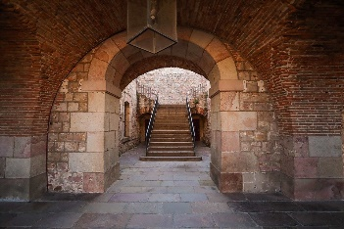[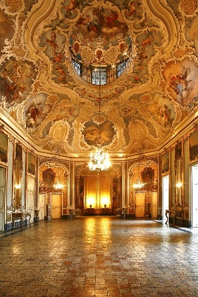](https://www.google.co.uk/url?sa=i&rct=j&q=&esrc=s&source=images&cd=&cad=rja&uact=8&ved=0ahUKEwiX7p3U_sfYAhXLKsAKHTHeAecQjRwIBw&url=https://www.pinterest.com/keepstrying/castles-and-palaces/&psig=AOvVaw2Bf3P2MvD3z_Sm9ECHnsRO&ust=1515487919920156)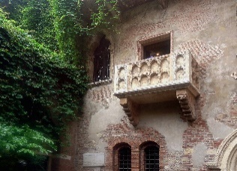= [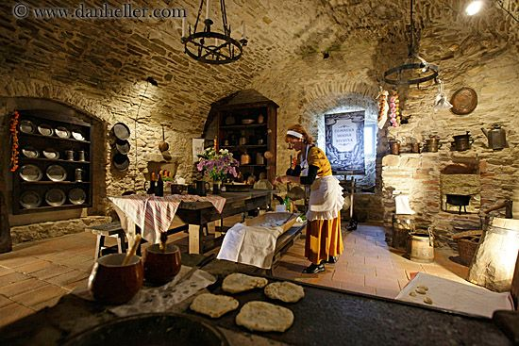](https://www.google.co.uk/url?sa=i&rct=j&q=&esrc=s&source=images&cd=&cad=rja&uact=8&ved=0ahUKEwi54cPDicjYAhXlJ8AKHZDsAnMQjRwIBw&url=https://www.pinterest.com/pin/844493650975513/&psig=AOvVaw3uypFv0CYYNgeqBfxg5dwa&ust=1515490239990160)

18m 2

24m 2

20m 2

6m 2

1. Cellar
2. Challenge – draw a floorplan of some of the rooms you could imagine there being in the Montague Property. Label each room with its perimeter.

Now, swap with a partner and check each other’s work.

1. Ballroom

4. Juliet’s balcony

1. Kitchen