ACT 4 : Poetry - Haiku

Summary of Act 4:

Sebastian Meets Olivia
Sebastian is confronted by Feste, Sir Andrew, Sir Toby and Fabian, who all think that he is ‘Cesario’. Sir Andrew strikes Sebastain and Sebastian fights back, thinking everyone is crazy. He almost gets into a sword fight with Sir Toby but Olivia interrupts them. She sends the others away and invites Sebastian to her house, believing he’s ‘Cesario’. Sebastian happily follows Olivia.

Visiting Malvolio
Maria and Sir Toby have locked Malvolio away in a dark room after claiming that he had gone mad. They get Feste to visit him, first in disguise as a priest called Sir Topas then as himself.

Wedding Bells
Sebastian is confused by the situation but decides that he likes Olivia. Olivia wants to marry Sebastian and Sebastian happily agrees!

Week 4 - Lesson 1: The Structure of a Haiku
Learning Intention | To understand the structure of a haiku poem
Key Vocabulary | haiku, syllables, lines, structure
Activities/  Lesson | Starter  - Give out a range of haikus (can be found online) on each table and allow the children time within their groups to read and explore the poems.  - Ask the children if they know what type of poem they are. What do they notice about the poems? How many lines does each poem have?  - Come back together as a class and take responses from the children. Explain to the children that the poems they have just been reading are called haiku poems.  - Explain that haiku poems originated in Japan. Haikus can relate to many themes.  - Explain that a haiku poem follows certain rules. Haikus are made up of three lines and each line must have a certain number of syllables.  - Explain that today they will further explore the structure of haikus, identifying the number of syllables which must be used in each line.  Main Teaching  - Ask the children what syllables are and explain that a syllable is a beat of sound within a word.  - Model saying single and multi-syllabic words aloud and clapping your hands to show the syllables within the word. Repeat this for several words and ask the children to join in- saying the word aloud and clapping their hands to show how many syllables the word consists of.  - Ask the children to choose words for the rest of the class to say and clap.  - Explain that this week we will be writing haikus based on Twelfth Night.  - Explain to the children that in a haiku poem, each line needs to be made up of a certain number of syllables.  - To help the children practise counting syllables within full sentences, give them the Count the Syllables sheet (see resources). Ask them to work in pairs and count and record the syllables in each sentence.  - Remind the children to say the words aloud and to clap the syllables to help them to count and record the correct number of syllables.  - Once complete, ask the children to share how many syllables there are per sentence and address any misconceptions.  - Working in pairs, ask the children to explore the haikus they read earlier and ask them to work together to count and record the number of syllables used in each line of the poem.  - See if the children are able to identify how many syllables should be used in each line.  • Line 1 - five syllables  • Line 2 - seven syllables  • Line 3 - five syllables  - To finish the lesson, ask the children to rehearse reading aloud their favourite haiku.
Notes for Teachers | - The children could further explore haikus in guided reading sessions.
Resources | - To print a range of haikus for the children to explore in pairs/small groups.  - To print the syllables table (see resources)

Week 4- Lesson 2: Expanded Noun Phrases

Learning Intention | To write expanded noun phrases for a haiku
Key Vocabulary | haiku, theme, unrequited love, love triangle, expanded noun phrases
Activities/  Lesson | Starter  - Display the love haikus (see resources) for the children to read.  - Check the number of lines and syllables per line to ensure it is a haiku poem. Remind the children of the structure of a haiku if they have forgotten.  - Then, ask the children what the themes of the poem are. The main theme is love! Ask them whether each haiku has a different mood although all 3 are about love.  - Ask the children which character from Twelfth Night could have written each haiku and ask them to explain how they know. Point out to them that the poems convey different aspects of love in the play E.g being in love/ unrequited love.  - Explain to the children that they will eventually write their own haiku poem based on love in Twelfth Night.  Main Teaching  - Show the images of love (see resources) on the board.  - Allow the children to discuss what each picture is referring to. Different children may have different interpretations of the picture.  - Jot the ideas down on the whiteboard. E.g. love triangle, Duke Orsino’s unrequited love, ‘Cesario’s’ hidden love for Olivia, Olivia falling in love, Sebastian falling in love, marriage, wedding etc. Explain that their haikus can be about any aspect of love that take place in the play.  - Explain that today we are going to work towards our haikus by generating expanded noun phrases.  - From these pictures ask the children to focus on specific nouns to do with love that they could write about. Ask the children to talk to their partner to come up with ideas. E.g. heart, eyes, hair, lips, love, touch, jealousy, heartbreak, pain etc. This could be tricky for some children so the class teacher should prepare a list of nouns that the children could create expanded noun phrases from.  - Recap expanded noun phrases and model creating a couple of expanded noun phrases using the nouns generated by the children.  - Watch the following video to support learning: https://www.bbc.co.uk/bitesize/topics/zwwp8mn/articles/z3nfw6f  - Ask the children to work in pairs to come up with expanded noun phrases for the different nouns.  - At the end of the lesson ask the children to feedback their ideas and allow children to ‘magpie’ any ideas that they like.
Notes for Teachers | - Ensure that there are plenty of opportunities throughout the lesson for the children to talk and share their ideas. The class teacher may have to direct them as some children may be less familiar with the plot of the play.
Resources | - Love Haikus (see resources)  - Images of love (see resources)

Week 4 - Lesson 3: Similes and Metaphors
Learning Intention | To create similes and metaphors
Key Vocabulary | similes, metaphors, figurative language, compare
Activities/  Lesson | Starter  - Ask the children to share what they know about similes and metaphors and why we use them.  - Explain that both similes and metaphors are a type of figurative language, and are used to create an image in the reader’s mind.  - Ensure that the children understand the difference between a simile and a metaphor.  • Simile – Uses the words ‘like’ or ‘as’ to compare something to something else. E.g.  as bright as the sun.  • Metaphor – Directly compares something to something else by saying that it is the  thing you are comparing it too. E.g. The snow is a white blanket  Main Teaching  - Explain to the children that similes and metaphors are used in poetry for effect and  today they will create similes and metaphors for their haikus based on the topic of love.  - Ask them to come up with nouns that we could write similes/metaphors for. E.g. love, eyes, heart, smile, heartbreak, hair, pain etc. Refer back to the nouns from yesterday’s lesson.  - With the children’s help, model writing simile and metaphors to describe love.  Examples:  - Simile (heartbreak) – stabbing like a sharp sharp knife (Seven syllables)  - Metaphor (eyes) – blinding stars in the night sky. (Seven syllables)  - Simile (love) - gentle like a fresh spring breeze  - Encourage the children to consider the number of syllables used in each simile and  metaphor and remind the children that these should be 5 or 7 syllables long.  - Ask the children to work in pairs to write similes and metaphors to describe the different nouns. Encourage them to check that they are 5 or 7 syllables long and include adjectives and  powerful verbs.  - At the end of the lesson, ask the children to read their similes and metaphors aloud to themselves. As they read these, they should clap out the syllables to check that they are 5  or 7 beats long.
Notes for Teachers | - The class teacher should prepare a bank of similes and metaphors prior to the lesson.
Resources | - Class teacher refers back to yesterday’s lesson for ideas of nouns that children could write similes and metaphors for.

Week 4 - Lesson 4: Writing haikus
Learning Intention | To write a haiku poem
Key Vocabulary | syllables, expanded noun phrases, similes, metaphors, topic, punctuations, capitalisation
Activities/  Lesson | Starter  - Create a checklist/success criteria for writing a haiku with the children and remind them of what they have learned in the last 3 lessons.  • Consists of three lines  • Line 1 - five syllables  • Line 2 - seven syllables  • Line 3 - five syllables  • Based on a topic  • could include expanded noun phrases  • could include similes  • could include metaphors  Main Teaching  - Shared Write: Display examples of expanded noun phrases, similes and metaphors from lessons 2 and 3 and ask the children to assist you in using these within your haiku.  - While writing each line of the haiku, model saying each line aloud and clap out the syllables to ensure it follows the rules of a haiku poem.  Example:  Unrequited Love  Bleeding, dying heart, (5)  like a thousand razor thorns, (7)  cutting a deep wound. (5)  - Once you have written your poem, read it aloud and clap out the syllables to check if it meets the rules of a haiku poem. If needed, model making changes.  - Discuss the use of capital letters, commas and full stops within the haiku.  - Explain that in poetry there are no hard and fast rules. Punctuation and capitalisation are up to the poet, and need not follow the rigid rules used in structuring sentences.  - Ask the children to write their own haikus based on the learning this week (expanded noun phrases, similes and metaphors).  - Recap the checklist/success criteria generated at the beginning of the lesson and leave this up on the board for the children to refer to.  - Encourage the children to write at least a few haikus. The more they practice writing, the more they will embed the structure of a haiku.
Notes for Teachers | - The class teacher should collect a bank of expanded noun phrases, similes and metaphors from the children’s work from day 2 and day 3. Display this on the board when shared writing haikus with the class during the teaching input.
Resources | - Ensure that children have access and refer to the expanded noun phrases, similes and metaphors that they generated in day 2 and day 3

Week 4 - Lesson 5: Drama - Performing Poetry
Learning Intention | To perform my haikus
Key Vocabulary | voice, intonation, tone, volume, expression, actions, speed, pause, accents
Activities/  Lesson | Warm Up  Poetry Ping Pong  - Read the poem Wet Play by Fi Calvert (see resources) to the children. The class teacher should read this poem modelling changes in intonation, tone, volume and use actions.  - Tell the children that to warm up we are going to play a game called Poetry Ping Pong.  - Write the line ‘Oh! Thank goodness- there’s the bell!’ on the board.  - Explain that for this game they have to work in pairs. Explain that they have to take it in turns to say the same line, batting it back and forth like ping pong.  - Tell the children that they cannot change the words or the order of the words. The challenge is that they have to say the line differently each and every time.  - Model saying the line ‘Oh! Thank goodness- there’s the bell!’ angrily then happily.  - Tell the children that they could think about how fast or slow they say the line or think about putting in pauses.  - Model varying the tone of your voice when saying the line and suggest that they could even say the line using different accents.  - Suggest that they could read the line in a specific role. E.g. saying the line like a newsreader or as though you’re telling a secret.  - Now ask the children for their ideas on how they could say the line.  - Allow the children to play poetry ping pong for 5 minutes. After the time is up, ask if any of the pairs would like to show their poetry ping pong to the class.  Main Activity  - Tell the children that today we are going to perform our haikus.  - Ask them to pick their favourite or most effective haiku that they wrote from yesterday,  - Ask them to think about the vocabulary used in their poems, the figurative language used and the effect the poem has on the reader.  - Tell them that they need to consider the following when performing for an audience and create a class checklist:  - Speak with confidence  - Vary pace (speed up and slow down where appropriate)  - Use actions  - Make eye contact  - Use intonation (their voice rises and falls where appropriate)  - Speak clearly  - Use good volume (change for effect where appropriate)  - Use expression  - Take the haiku that you wrote with the class from yesterday’s lesson and work together as a class to read this. Select children to read a line from your poem and discuss the intonation, volume, expression, pace, etc.  - Tell the children that they have 15 minutes to practice performing their haiku. Prompt the children to refer to the checklist above.  - After 15 minutes, ask each child to recite and perform their poem to the class.
Notes for Teachers | - Class teacher to practise reading the poem Wet Play by Fi Calvert with intonation, tone, volume and actions prior to the lesson.  - This lesson should take place in a hall where the children have space to move around.  - The class teacher might want to find videos of poems being performed for the children to watch and analyse.
Resources | - Wet Play by Fi Calvert (see resources)
Resources

Count the Syllables

Sentence | Number of syllables
I went on holiday last year.
I have eleven siblings.
My dog loves eating chicken and chips.
My best friend’s name is Alex.
It has been snowing for a week.
We have assemblies on Monday.
I like to read at night.
It’s my birthday in two weeks.

Sentence | Number of syllables
I went on holiday last year.
I have eleven siblings.
My dog loves eating chicken and chips.
My best friend’s name is Alex.
It has been snowing for a week.
We have assemblies on Monday.
I like to read at night.
It’s my birthday in two weeks.

Love Haikus

Without you I’m empty,
a tree with no leaves at all,
but you have said yes!

I love her but he
loves him. My Olivia
I love you always.

Your eyes like diamonds
stare into my soul. Your kind
smile beckoning me.

Images of Love

(iStock)
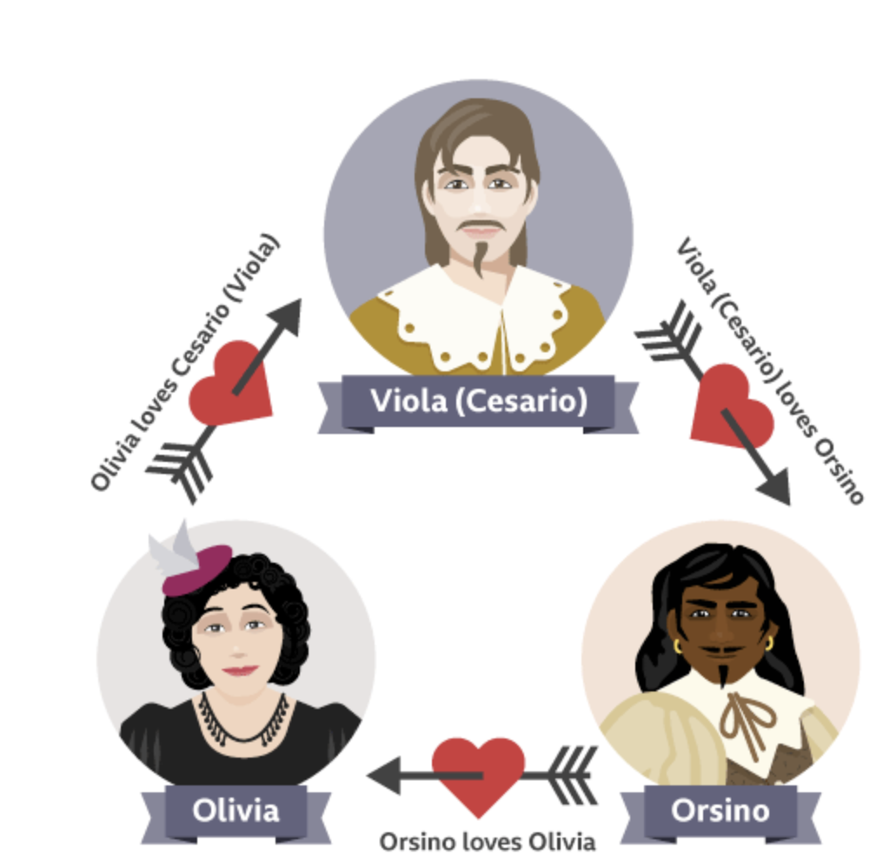BBC Bitesize

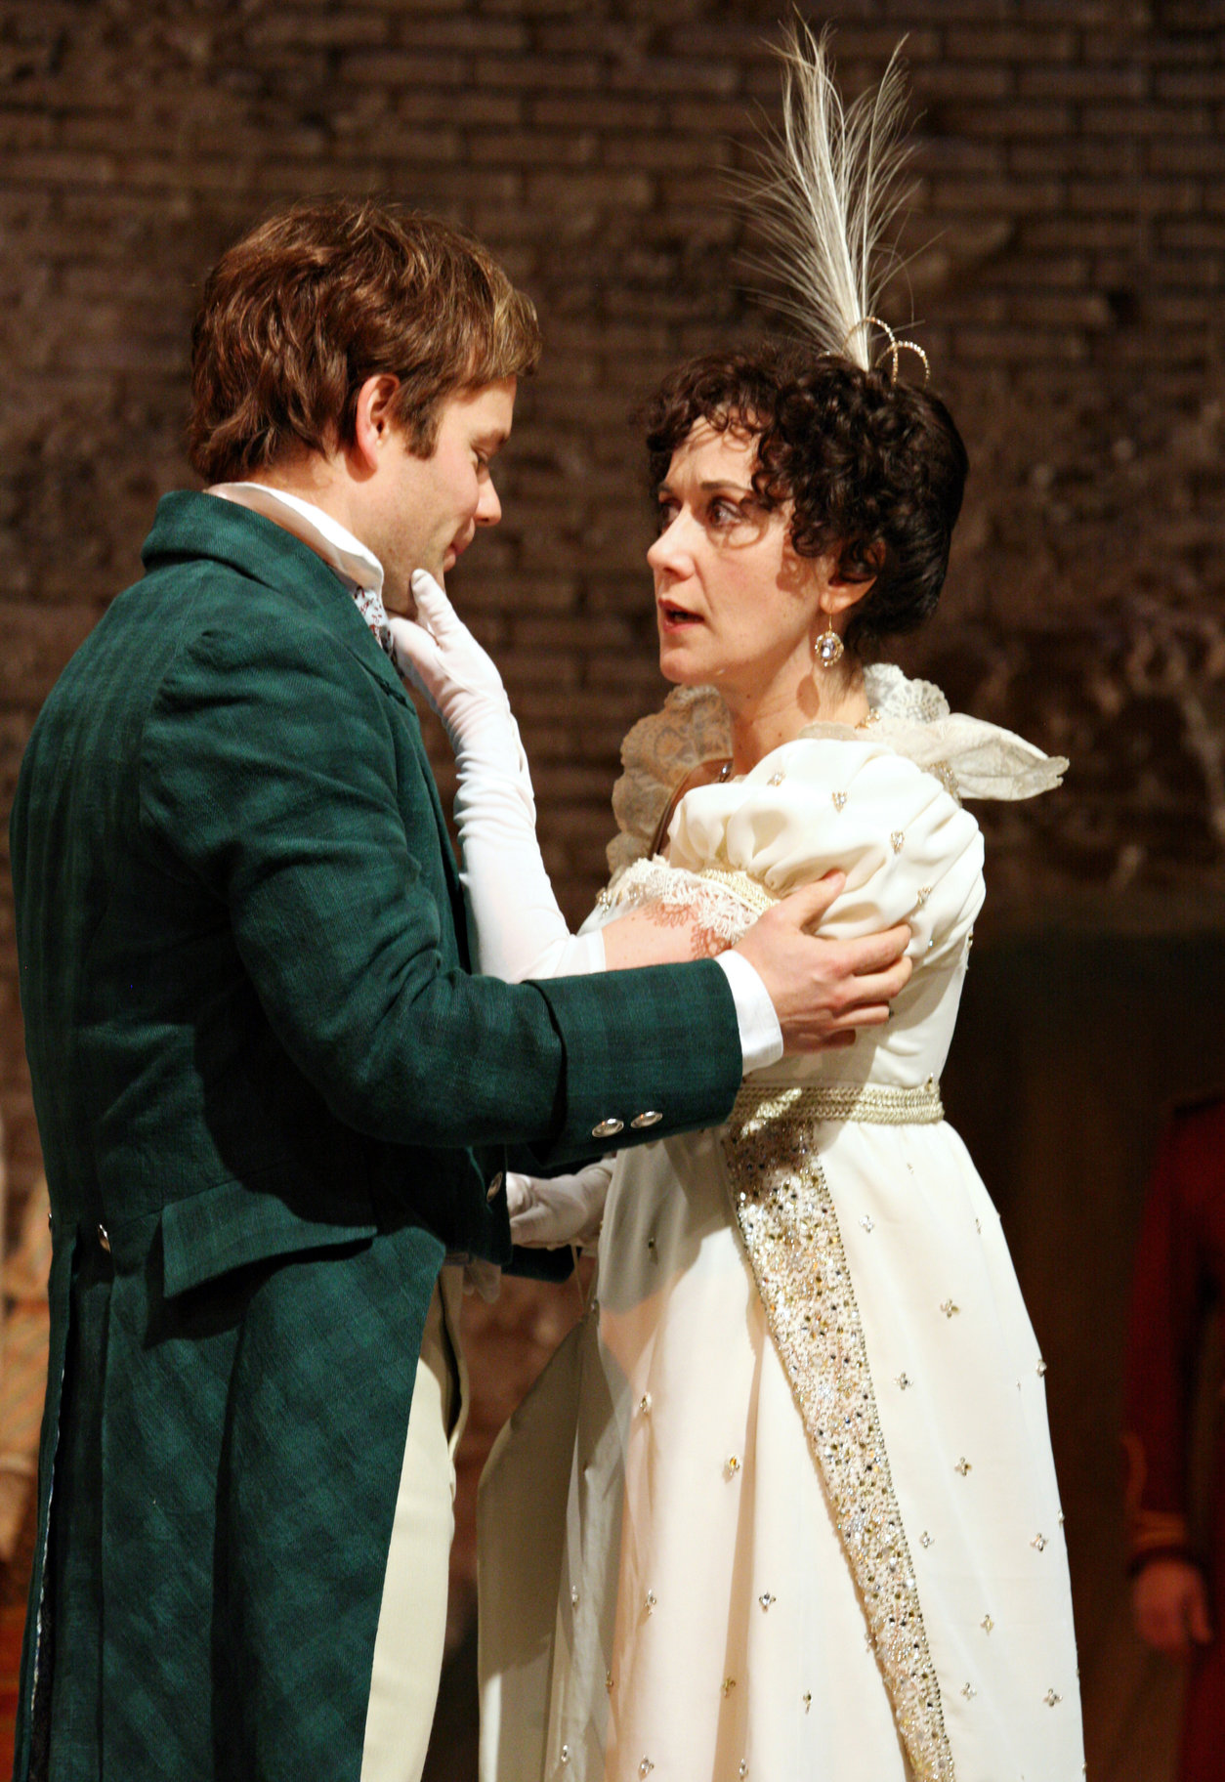
Royal Shakespeare Company

iStock

Shuttershock

bbc Bitesize

Wet Play by Fi Calvert

“Wet play!” The teachers say.
Everybody shouts “Hooray!”
“Games out! Let’s not shout!
Tommy, please don’t run about!”

Hatty builds a Lego tower,
Ashton colours in a flower.
Fern and Krishna play Top Trumps,
Lottie’s on a chair, then ...
JUMPS!

“Get up Lottie! Do not climb
and jump around. I’ve got no time
for children who do silly things,
and act as though they’ve sprouted wings.”

Lottie settles down to draw,
Lou is rolling on the floor.
Tommy (who’s still running round)
trips on Lou and hits the ground.

“What on earth is going on?
Playtime’s not five minutes gone.
Settle down now, please just play
quiet as mice or - games away!”

Every child’s now on a chair,
Benji’s styling Harvey’s hair
(not with gel - he’s using glue!)
Abigail has lost a shoe.

“Harvey, what’s that in your hair?
Really kids! I do despair!
Hang on Abi, where’s your shoe?
Children this is like a zoo!”

BRRRIIIIIIINNNNG!

“Oh! Thank goodness- there’s the bell!”
This wet play has not gone well.
I think a book, now, would be best.
After that we need a rest!”

