Multiply the Ingredients for the Wedding Banquet
At the wedding, Prospero introduces the masque. In the sixteenth and seventeenth centuries, masques were popular forms of entertainment in England. Masques featured masked actors performing allegorical, often highly ritualized stories drawn from mythology and folklore. They then sat down to have a banquet. They don’t have much time to prepare and need your help to work out the quantities of ingredients that they will need.
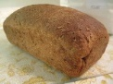
For the bread:
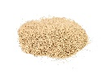
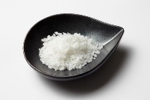
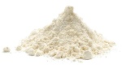
11 x 8g of salt =
8 x 2g of salt =
9 x 9g of flour =
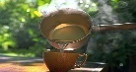
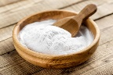
6 x 7ml of warm water =
5 x 6g of baking soda =
7 x 8ml of milk =

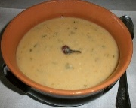
For the Maccu Soup:

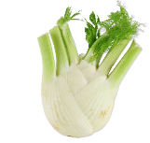
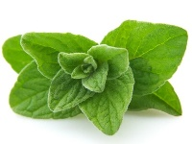
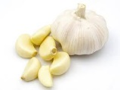
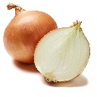
3 x 7g of fennel =
2 x 8g of oregano =
10 x 8g of garlic =
12 x 4g of onion =
9 x 6g of beans =
11 x 4g of fava beans =

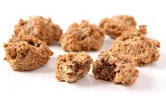
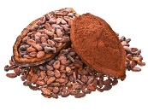
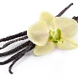
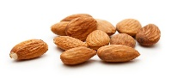
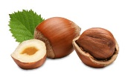
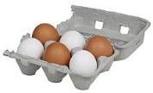
For the Bruttiboni:
9 x 5g of cocoa =
7 x 7g of vanilla=
8 x 8g of sugar =
6 x 4g of almonds =
7 x 3g hazelnuts =
9 x 8 eggs =

