A cast are preparing to put on a performance of Romeo and Juliet but first, they need to get the numbers in order…
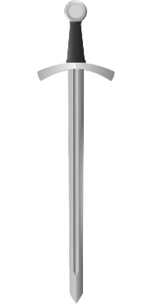
Act 1, Scene 1 - Montague V Capulet brawl
In the first minute of the fight, swords were swung a total of 1436 times.
In the second minute of the fight, swords were swung a total of 1331 times.
In the third minute of the fight, swords were swung a total of 1415 times.
In the fourth minute of the fight, swords were swung a total of 1442 times.
In the fifth minute of the fight, swords were swung a total of 1397 times.
Order the minute had the least sword swings to the minute that had the most (write, ‘third minute’).
………………………… ………………………… ………………………… ………………………… …………………………

Act 1, Scene 2 – The Invitation
Peter is asked to deliver invitations to the Capulet feast for Paris to try and win Juliet’s heart.
He takes them to 4 different districts in Verona: Veronetta, Valdonega, Borgo Roma
And San Zeno.
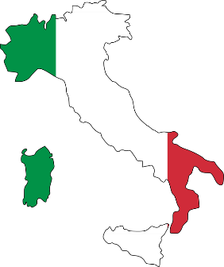
To Veronetta, Peter delivers 2189 invitations.
To Valdonega, Peter delivers 1191 invitations.
To Borgo Roma, Peter delivers 1881 invitations.
To San Zeno, Peter delivers 2198 invitations.

Order the districts. Start with the district that had most invitations delivered.

……………………… ……………………… ……………………… ………………………

Act 1, Scene 3, - The Feast – help the cooks to order the food items
- ………………………………………

- ………………………………………

- ………………………………………

- ………………………………………

- ………………………………………

- ………………………………………

- ……………………………………...

- ………………………………………

- ………………………………………

- ………………………………………
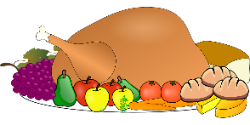
from: 1. Dishes that they need the most of -
10. Dishes that they need the least of

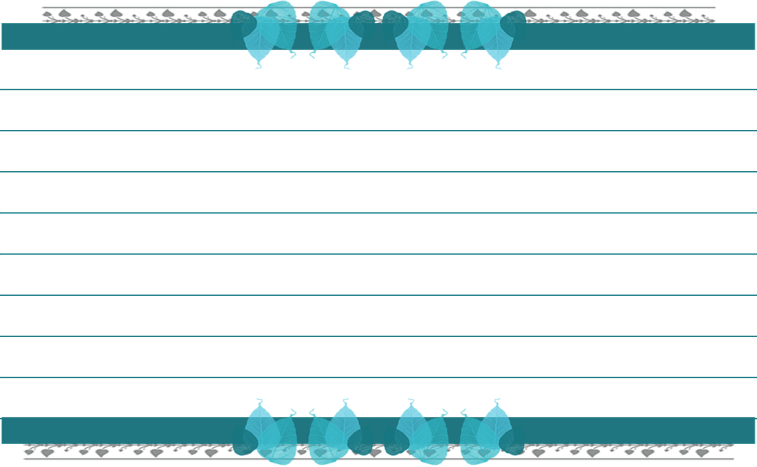
Slices of almond cake 1897

Portions of raspberry pudding 1682

Bowls of gooseberry fool 1719

Bowls of mixed cooked greens 1907

Fresh bread rolls 1812

Bowls of oxtail soup 1504

Roasted venison 1754

Boiled mutton 1681

Baked pies 1779

Oysters 1876

