Sampson and Abram are bragging and trying to
Sampson | Abram | Who has more? And how many more do they have?
“The Montagues have got more swords than the Capulets!” | “No, way. The Capulets have more!”
“The Montagues have more money than the Capulets will ever have!”  120  coins  120  coins  120  coins  120  coins | “I doubt that very much!”  170  coins  170  coins  170  coins
“My Master has countless masks for celebrations.”  190  masks  123  masks | “Oh give it up already! My Master has far more…”  140  masks  175  masks
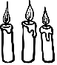  “The Montagues have so many beautiful candles. More than you could even count!”  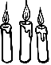  203  candles  326  candles  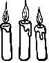 | “…oh, this bragging is getting tiring now! We definitely have more candles!”  627  candles  118  candles
“For our banquet, we have so many delicious bread buns!”  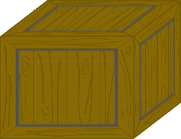  556  buns  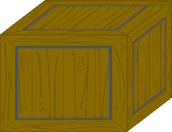  289  buns | 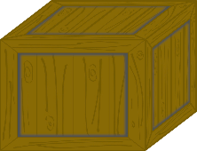  “Well at our banquet, guests will be so full of lovely, fresh bread!”  207  buns  113  buns  195  buns
get one over on each other. For each idea, who is right?

