Juliet is distraught when Friar Laurence tells her that there’s nothing he can do anything to prevent her having to marry Lord Paris. She is desperate for a way out so Friar Lawrence hatches a plan. He says that Juliet can take a potion that mimics death, ‘The roses in thy lips and cheeks shall fade. To paly ashes, thy eyes' windows fall, 100. Like death, when he shuts up the day of life’.
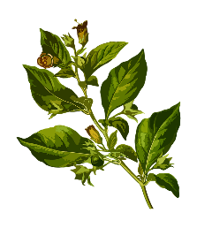
Potions and poisons were often made using plants. The person, who Friar Laurence got the potion from, made a large quantity, before pouring it into many little bottles. Work out how much of each ingredient is needed for the potion:

1723 lots of 14ml of hemlock…
1282 lots of 18ml of wild pansy…
5121 lots of 23ml of yew…
1321 lots of 19ml of deadly nightshade…

7453 lots of 45ml of leopard’s bane…
1256 lots of 34ml of crushed bulrush…
9123 lots of 24ml of ebony…
1652 lots of 53ml of wild rosemary…

3404 lots of 59ml of peaseblossom…
6654 lots of 91ml of mustard seed…
8190 lots of 65ml of violets…
7612 lots of 78ml of fennel…

W

Write 3 multiplication (4 digit x 2 digit) problems about ingredients for your own poison. Make them different to the ones above. Ask a peer to solve the problems.

