ACT 3: Newspaper Report

Summary of Act 3:

Olivia’s Confession
OIivia meets ‘Cesario’ and confesses her love for ‘him’.

Sir Andrew
Sir Andrew realises that Olivia is not interested in him so he decides to leave. He is then convinced by Sir Toby and Fabian to challenge ‘Cesario’ to a duel.

In Yellow Stockings and Smiling
OIivia sends for Malvolio and is shocked to see him wearing yellow stockings and smiling at her (everything that is asked of him in the letter). Maria and Sir Toby use this as an excuse to say that Malvolio has lost his mind and they lock him up in a dark room.

Fight!
Sir Toby tells ‘Cesario’ that Sir Andrew is waiting to fight him. Sir Toby and Fabian go between the two of them telling each of them lies about the other. ‘Cesario’ and Sir Andrew fight each other. Antonio tries to stop them thinking that ‘Cesario’ is Sebastian. Antonio is arrested.

Under Arrest
Antonio arrives just as ‘Cesario’ and Sir Andrew begin to fight. Antonio tries to stop them, thinking that he is defending Sebastian. At that moment, officers arrive to arrest Antonio for his past crimes against Orsino. Antonio asks ‘Cesario’ for help but 'Cesario' says that he doesn’t know him.

Week 1 - Lesson 1: Features of a Newspaper Report
Learning Intention | To understand the features of a newspaper report
Key Vocabulary | headline, orientation sentence, main body, photograph, caption
Activities/  Lesson | Starter  https://www.bbc.co.uk/bitesize/topics/z2yycdm/articles/z2gk9qt  - Play the above film clip to introduce newspapers to the class. Discuss why people read newspapers and what features we might expect to see in a newspaper.  Main Teaching  - Show an example of a newspaper report on the IWB (see resources).  - Start to read it aloud to the children, asking them to follow the words as you read. Then ask some members of the class to take turns reading aloud.  - Repeat this activity, but now ask the children to read the newspaper with their partners, taking it in turns to read the different paragraphs.  - Ensure that the children are working in mixed ability pairs so that they can support each other’s learning.  - Ask them what they notice about the newspaper report. Can they remember any of the features they saw in the clip at the beginning of the lesson?  - Give each pair 5 Postits and ask them to write one of the following newspaper features on each Postit:  - Headline  - Orientation paragraph (when, what, where, who)  - More detail about event paragraph (how, why)  - Quotation paragraph  - Reorientation paragraph (present tense – what will happen now?)  - Ask them to work with their partners to identify each part of the newspaper in the example they have been reading.  - Take feedback from the class. Ask different children to come up to the front and stick the pieces of paper next to the correct paragraph using Blue-tac.  - Now show the children the following features of a newspaper report:  - Mainly past tense  - 4Ws in the orientation sentence (what,when,where,who)  - Third person  - Time adverbials (e.g. afterwards, later, at 5 o’clock)  - Chronological order  - Quotation with speech marks  - Paragraphs to organise ideas  - Give each pair a copy of the newspaper report on A3 paper. Model using a felt tip pen to highlight examples of words in the past tense and label using a ruler.  - Ask children to do the same on their piece of paper.  - Repeat for the next feature (4Ws in the orientation sentence) using a different colour pen.  - When you are confident that the children understand the task, ask them to work through the rest of the features with their partner and finish annotating their sheet.  - After about 10-15 minutes, take feedback from the class and ask different partners to give an example of each feature.  Plenary  - Ask children to write down as many features of newspaper reports as they can remember. - They then choose 4 different features and record on a whiteboard in a Bingo style grid. Call out features for children to cross off until one child crosses out all four features in their board and calls out Bingo!
Notes for Teachers | - See ‘Resources’ box below for the preparation for this lesson.  - Class teachers should read and tailor the writing examples provided to suit the needs of the class.
Resources | - Print copies of the example newspaper report 1 for this lesson (see resources).

Week 1- Lesson 2: Drama

Learning Intention | To understand the key events of the fight
Key Vocabulary | Chronological order, events, hot-seating, eyewitness, statement, quotations
Activities/  Lesson | Warm Up  - Explain to the children that in Act 3, there is a fight scene between Sir Andrew and Cesario and that this week we are going to write a newspaper report about the fight.  - Tell the children the names of the main characters who are part of the fight scene. For each character, show the children an action and tell them a line explaining their role in the fight. (see writing in bold).  - Sir Toby (Olivia’s Uncle): Whispered and gossiped to start the fight  - Sir Andrew: Fought Cesario for Olivia’s heart  - Cesario: Did not want to fight but had no choice!  - Antonio: Thought Cesario was Sebastian and tried to save him  - Police Officers: Recognised Antonio and arrested him  - The children should repeat each action and their role back to you until they have memorised each one.Once they have learnt them, they need to do the action and say the quotation each time you say the name of the character. You could also switch this around. You do the action and say the role, and they have to say the name of the character.  - Encourage the children to use expression in their voices and large actions. (N.B. you will need to think of a simple action for each character). Praise children who are doing this well and ask them to demonstrate to the class.  Main Activity  Part 1: Main Events  - Split the children into groups of 5 and give each group a set of the main events of the fight scene (see resources).  - Ask them to take an event each, read it aloud to their group and order the events in chronological order.  - Once the children have established the order, review the order with the class to check that every group has ordered the events correctly.  - Tell them that each of them will play one of the five characters in the scene (Sir Toby, Sir Andrew, Cesario, Antonio and a police officer) and they have 10 minutes to ask out the scene in the correct order. Encourage the children to use expression, body language and voice to convey feeling.  - Pick a couple of groups to perform for the class.  Part 2: Hot-Seating  - Now that the children have acted out and understand what happened in the fight scene, explain that they will now be acting as journalists doing some research for a newspaper report they are writing about the fight that took place.  - Pick someone to act as an eyewitness. This person should sit on a chair at the front of the class, while the rest of the class (the journalists) sit on the floor facing them.  -The journalists will be asking the guest questions about the party and will need to write down the responses they hear.  - The teacher should first model asking questions to the eyewitness (e.g. What were you doing before the fight started? Who was at the scene?) and then the ‘journalists’ should start to think of their own questions.  - After a few questions, pick a different child to act as a different eyewitness.  - Make sure that children are recording the responses of the eyewitnesses in their books as these will be used as quotations in their newspaper report later in the week. Ask the child acting as the eyewitness to pause after speaking so the children have time to record what is being said.
Notes for Teachers | - You will need to think of a simple action for each character for the warm up activity prior to the lesson
Resources | - Cut up and shuffle the main events of the fight scene (see resources) so that each group has a set

Week 1 - Lesson 3: Headline and Orientation
Learning Intention | To write an effective headline and orientation paragraph
Key Vocabulary | headline, orientation, alliteration. rhyme, present tense, puns
Activities/  Lesson | Starter  - In partners, ask the children to think of as many words as they can based on the pictures of the fight scene (see resources).  - Ask them to share the words they have come up with and record on the whiteboard. Model using a thesaurus to find synonyms to some words (such as ‘fight’). Children work with a partner to find synonyms for some of the words on the list. Share with each other and add new words to the whiteboard. These words will be used as a word bank to help the children with writing their headline.  Main Teaching  Part 1: Headline  Show children examples of headlines from newspapers and ask them discuss what makes a good headline:  Short and snappy  Eye-catching  Present tense  *Alliteration (optional depending on children’s ability)  *Rhyme(optional depending on children’s ability)  - Model using the word bank to think of catchy headlines for the fight. Children work in mixed ability pairs to think of their own headline and record in their books.  Part 2: Orientation Paragraph  - Ask the children what the first paragraph of a newspaper is called (the orientation paragraph). Explain that it is a simple paragraph with only one or two sentences which briefly tells the reader what happened, when it happened, where it happened and who was involved. - Tell the children that it is an important paragraph because it tells the reader what the rest of the report is about and helps them decide if they want to read on or not.  - Children should then work with a partner to have an opportunity to practise writing a clear and simple orientation paragraph using the following keys facts:  When: Wednesday afternoon  Who: Sir Andrew, Cesario  What: duel/fight  Where: at Lady Olivia’s house  - Children share their orientation paragraphs with the class. Highlight good examples/address any misconceptions.  - Having practised writing a paragraph in pairs, the children should now write their own orientation paragraph for their newspaper report on the fight, using the following success criteria to support them:  - Past tense  - Only one or two sentences  - State the key facts (4 Ws)  - Ask children to share their orientation paragraphs. Other children to say whether it is a successful orientation paragraph with reference to the success criteria.
Notes for Teachers | - The success criteria should be accessible to the children when they are writing the orientation paragraph.
Resources | - Prepare a bank of effective headlines

Week 1 - Lesson 4: Main Body
Learning Intention | To write the main body of a newspaper report
Key Vocabulary | chronological order, fronted adverbials
Activities/  Lesson | Starter  - Display the example of the newspaper report from lesson 1 and ask the children to work in pairs to pick out time fronted adverbials that they might use in their own writing.  - Children share the sentence starters they have identified and the teacher records them on the whiteboard. Can they think of any others they might use?  Main Teaching  - Now ask the children to think about the events of the fight scene. What interesting things happened that night? They discuss with their talk partner.  Now show the children the following key events in a random order (see resources):  - Sir Toby takes turns to talk to Sir Andrew and ‘Cesario’- encouraging both of them to fight each other.  - Sir Andrew draws his sword to challenge ‘Cesario’ to a duel.  - ‘‘Cesario’ does not want to fight but reluctantly draws his sword in defense.  - The two men begin to fight but then Antonio enters the scene. He mistakes ‘Cesario’ as Sebastian so he wants to save him. Antonio offers to fight Sir Andrew instead.  - Several police officers burst onto the scene. They have recognized Antonio -a wanted man in Illyria—and arrested him.  - Ask them to arrange the pieces of paper so that the events are in chronological order (remind children of what this means).  - Once they are happy with the order, they should stick the pieces down onto another piece of paper. This will help the children write the next paragraph of their newspaper.  - Take feedback from the class and make sure they have the events in the correct order.  - Remind children that, in the next paragraphs, they need to report what happened at the ball in chronological order, using time-fronted adverbials to help them structure their paragraph (refer children to the list made at the beginning of the lesson). They should also add detail to make the report more interesting for their reader.  - Model writing the first few sentences of the paragraph, reporting the events in order. Ask the children to help you once you have modelled the first sentence.  - Ask them what they need to include in their writing to make it successful, before setting them off on the task. They should use the plan that they worked on with their partner to help them write in chronological order.  - Past tense  - Chronological order  - Fronted adverbials of time  - Further details about the party  - Editing: At the end of the lesson, the children should read their paragraph to a partner to help them edit their work. They should look out for missing words and punctuation as well as making sure their writing makes sense.
Notes for Teachers | - Make sure that time fronted adverbials are displayed somewhere in the classroom to help the children when they are writing.
Resources | - It would be useful to create a word mat with common vocabulary and sentence starters for the children to refer to when writing the main body of the report.

Week 1 - Lesson 5: Witness Statement and Publishing
Learning Intention | To use speech marks correctly to report direct speech.
Key Vocabulary | eyewitness statement, quotation, speech marks
Activities/  Lesson | Starter  - Show the children some sentences where the speech marks are missing. Remind children what speech marks look like and why they are used – they go around direct speech to show us what someone has said.  - Then ask children to come up to the board and put the missing speech marks in the correct place:  I saw Sir Andrew draw his sword first, he said.  It was such a shock to see them duelling in the courtyard, she said.  It has been years since we have seen fighting in Illyria. Everyone who witnessed the fight was stunned by the commotion, she said.  - Model the use of commas, question marks and exclamation marks at the end of speech, rather than full stops.  Main Teaching  - Ask children to look back at the notes they made at the end of the drama lesson earlier in the week (from the hot-seating activity).  - Ask them to pick one quotation that they are going to include in their next paragraph. They should record this on their whiteboard. Ask a few children to share their quotations with the rest of the class, using expression.  - Ask the children to think of an appropriate name for their guest and add it to their whiteboard. e.g. Maria, Fabian etc.  - The children are now ready to write their paragraph with an eye-witness account, using the information on their whiteboards to help them.  - Model writing the next paragraph.  Example:  Lady Olivia’s maid, Maria, was shocked by the whole incident . “I couldn’t believe my eyes! It has been years since a fight had broken out in peaceful Illyria.’’  - Ask the children what will make their writing successful:  - speech marks in the correct place  - name of guest  - quotation  - Now ask them to complete this paragraph, using their whiteboards to help them.  - Once the children have written and checked this paragraph, ask some to share their newspaper reports so far.  - Finally, ask the class how they think the report needs to end.  - Direct the children to end their report on what is happening next. What do the police have to say? What are the police planning to do now?  - Children use modelled examples to help them finish their own newspaper.  Publishing  - Once the children have edited and checked their whole report, they should publish their reports in an afternoon session, adding appropriate pictures and captions.  - Use the newspaper report template (see resources) and print in A3 for the children to publish on.
Notes for Teachers | - Make sure that children have their work from the hot-seating activity from lesson 2 for this lesson.
Resources | - Print the newspaper report template (see resources) in A3 for publishing.

Resources

Example Newspaper Report 1 (to be edited by class teachers)
(Image - Royal Shakespeare Theatre 1974)

Neighbours Notice Nobleman Fighting
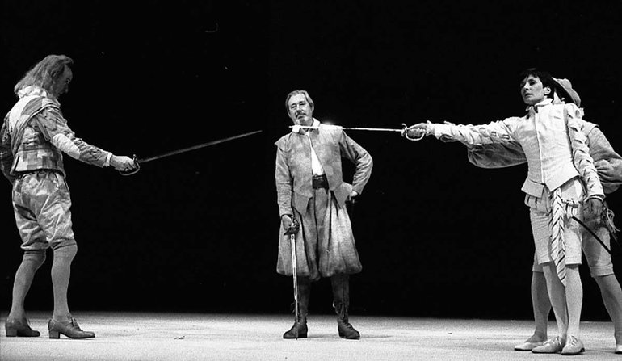
Sir Andrew and Cesario fighting in Lady Olivia’s courtyard

Yesterday afternoon, a brawl broke out at Lady Olivia’s residence between Sir Andrew and Duke Orsino’s page boy, Cesario. The reason for the fighting is unknown however onlookers suspect that the perpetrators were duelling over the noble Lady Olivia.

At 3 o’clock on Wednesday afternoon, a dispute erupted as Sir Andrew challenged Cesario to a duel. According to eyewitnesses, Sir Toby Belch was spotted talking to both men before the fight started. Sources say that Sir Toby was aggravating the situation which eventually led to swords being drawn.

Later on in the day, servants of the household reported that Sir Andrew was the first to draw his sword starting the battle. Neighbours, who were watching from their windows, reported that Cesario only drew his sword after Sir Andrew did in order to defend himself. The men duelled for only a few minutes when a man, thought to be in his twenties, interrupted Sir Andrew and Cesario mid-fight. Almost immediately after the unknown man broke up the fight, police officers arrested the man. Grace Cicero, one of Lady Olivia’s maids, overheard the police officers who arrested the unknown man. “We heard the officers call the man by the name of Antonio and said that he was under arrest for old crimes that he’d committed in Illyria. From what I gather, this man must be a fugitive of some sort!”

The police say that they are still investigating the incident that took place at Lady Olivia’s home and have asked for eyewitnesses to step forward to help the police solve this case.

Example Newspaper Report 2 (to be edited by class teachers)
(Image - George Clint: The Duel between Sir Toby and Sebastian

Foolish Fight Disrupts Peaceful Illyria
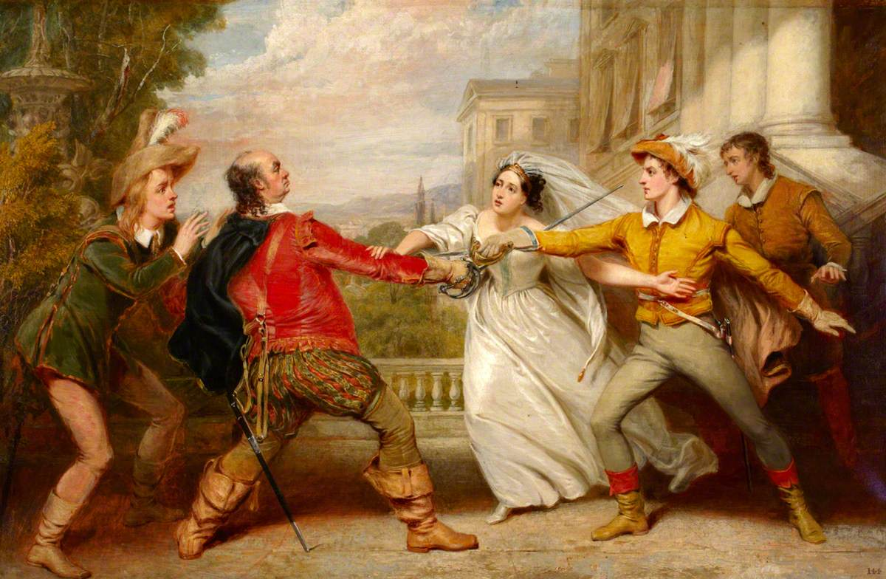
The police are still investigating the cause of the fight which took place on Wednesday afternoon

On Wednesday afternoon, Sir Andrew and Duke Orsino’s page boy, Cesario, were witnessed duelling in Lady Olivia’s courtyard. Police are still investigating and do not yet know why the unruly incident took place.

Reports suggest that Sir Andrew challenged Cesario to a duel out of jealousy. Lady Olivia’s servants reported that, like the Duke, Sir Andrew also has his heart set on marrying Lady Olivia. However, it has been suggested by many that Lady Olivia is madly in love with Cesario and has refused all other marriage proposals. The police are yet to confirm these claims and have asked the public to refrain from gossip while they investigate the case. The duel ended abruptly as an unknown man rushed onto the scene of the fight. He was followed by a large group of police who arrested the man claiming that he is under arrest for several crimes. Neighbours, servants and bystanders were bemused by the commotion.

Sir Toby, Lady Olivia’s uncle and a good friend of Sir Andrew, was at the scene and watched the terrible events unfold. “I am shocked and appalled that Sir Andrew would stoop so low to duel with a page boy! I tried to reason with him and keep him calm but we all know that love can affect people in unexpected ways. It is despicable behaviour.”

The violence that took place on Wednesday is still being investigated by the police. In a bid to keep the streets of Illyria safe, they have issued an official warning that such fighting and disorder will not be tolerated and anyone involved in duelling will be arrested and charged.

Main Events - Fight Scene

Sir Toby takes turns to talk to Sir Andrew and ‘Cesario’- encouraging both of them to fight each other.

Sir Andrew draws his sword to challenge ‘Cesario’ to a duel.

‘Cesario’ does not want to fight but reluctantly draws his sword in defense.

The two men begin to fight but then Antonio enters the scene. He mistakes ‘Cesario’ as Sebastian so wants to save him. Antonio offers to fight Sir Andrew instead.

Several police officers burst onto the scene. They have recognized Antonio -a wanted man in Illyria—and arrested him.

Fight Scene Pictures

George Clint: The Duel between Sir Toby and Sebastian

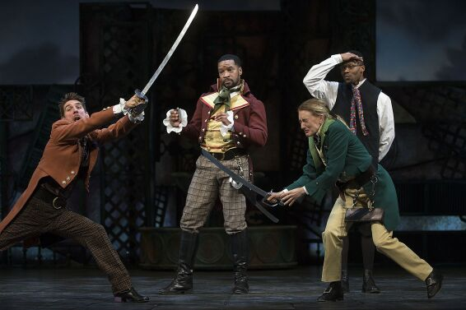
Conner Marx as Sir Andrew Aguecheek, left, Kenajuan Bentley as Sir Toby Belch in Pioneer Theatre Company’s production of William Shakespeare’s “Twelfth Night,”

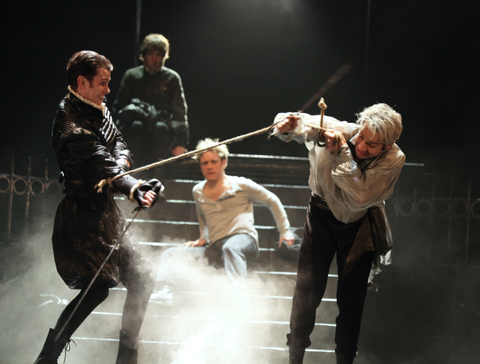
Romeo and Juliet, The Royal Shakespeare Company, Courtyard Theatre, Stratford-upon-Avon

Newspaper Template (print A3)

