
THE WINTER’S TALE
ACT 3

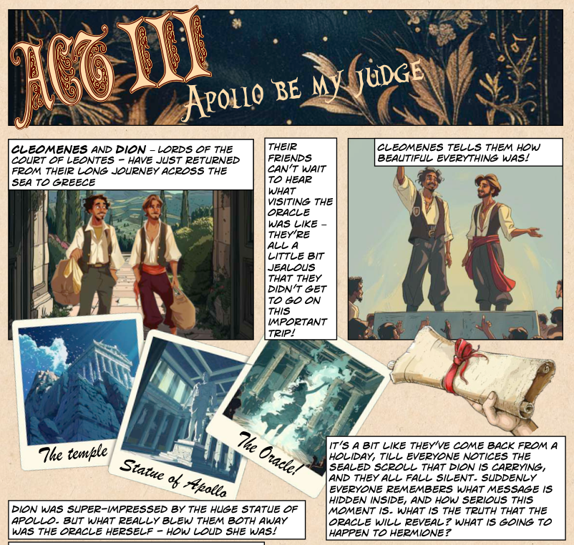

- Complete the phrase below

______________ be my judge

- Where have Cleomenes and Dion just returned from?

________________________________________________________

- What word is used in the text to describe their journey?
Tick one box

Fast Exciting

Long Tiring
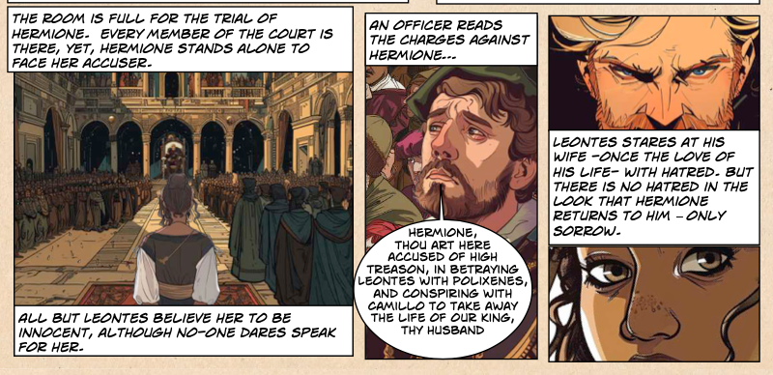

- Who is on trial?

______________________________

- Do people believe she is

Guilty Innocent

- Write down two things that Hermione is accused of?

_____________________________________________________

_____________________________________________________

_____________________________________________________

- Does Hermione hate Leontes?

YES NO

Explain your answer with reference to the text

_____________________________________________________

_____________________________________________________

_____________________________________________________

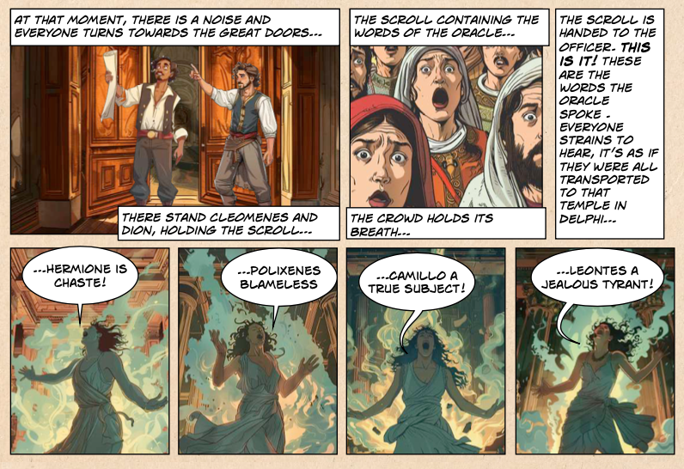
- What holds “the words of the Oracle”? Write one word

_____________________________________________________

- Why does “the crowd hold it’s breath”?

_____________________________________________________

_____________________________________________________

_____________________________________________________

- Draw lines to the complete the words of The Oracle

Hermione is chaste

Camillo a jealous tyrant

Polixenes is blameless

Leontes a true subject

- Does The Oracle agree with Leontes

YES NO
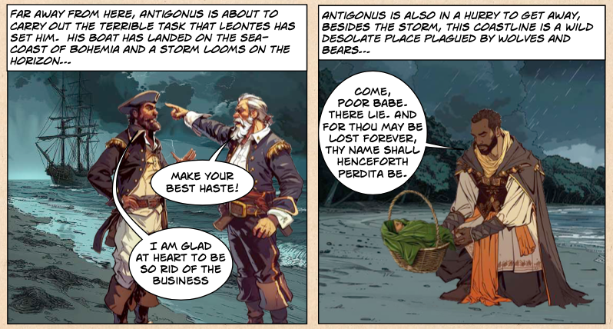
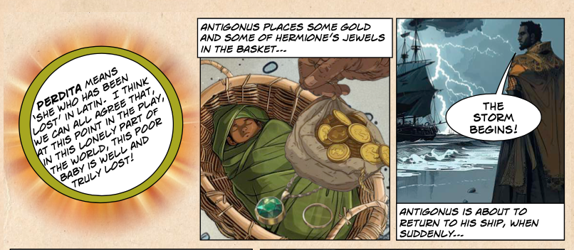

- Where does Antigonus’ boat land?
Off the coast of…

Sicilia Ireland

Greece Bohemia

- What name does Antigonus give the baby he is leaving?

________________________________________________

- What does this name mean?

_____________________________________________________

_____________________________________________________

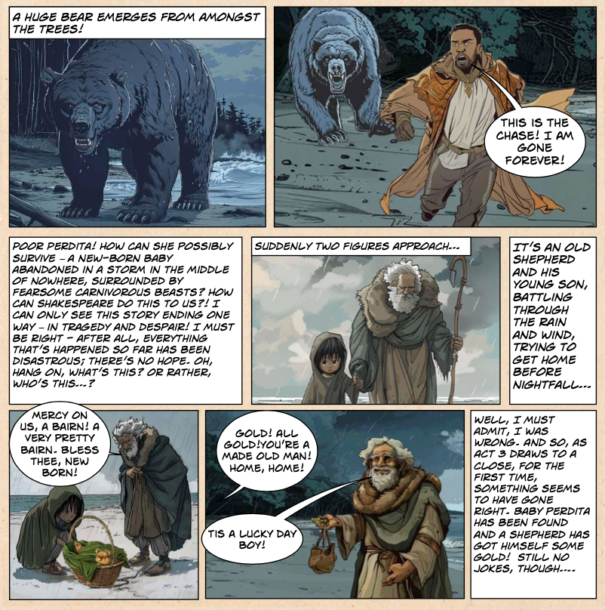
- What happens as Antigonus is about to return to his ship?

_____________________________________________________

_____________________________________________________

- Who finds the “bairn”?

_____________________________________________________

_____________________________________________________

- What does ‘bairn’ mean?

_____________________________________________________
THE WINTER’S TALE
ACT 3
ANSWERS
- Complete the phrase below
Apollo be my judge
- Where have Cleomenes and Dion just returned from?
Greece
- What word is used in the text to describe their journey?
Tick one box
Long

- Who is on trial?
Hermione

- Do people believe she is
Innocent

- Write down two things that Hermione is accused of?
Betraying Leontes with Polixenes
Conspiring with Camillo

- Does Hermione hate Leontes?
NO
Explain your answer with reference to the text
It says that Leontes “stares at his with with hatred” but “there is no hatred in the look that Hermione returns- only sorrow”

- What holds “the words of the Oracle”? Write one word
Scroll
- Why does “the crowd hold it’s breath”?
Because they are so excited/nervous about hearing whether Leontes is right or wrong in his accusations against Hermione.
- Draw lines to the complete the words of The Oracle
Hermione is chaste
Camillo a true subject
Polixenes is blameless
Leontes a jealous tyrant

- Does The Oracle agree with Leontes
NO
- Where does Antigonus’ boat land?
Off the coast of…
Bohemia

- What name does Antigonus give the baby he is leaving?
Perdita
- What does this name mean?
“she who has been lost”

- What happens as Antigonus is about to return to his ship?
He gets chased/eaten by a bear

- Who finds the “bairn”?
A shepherd and his son

- What does ‘bairn’ mean?
baby

