
THE WINTER’S TALE
ACT 4
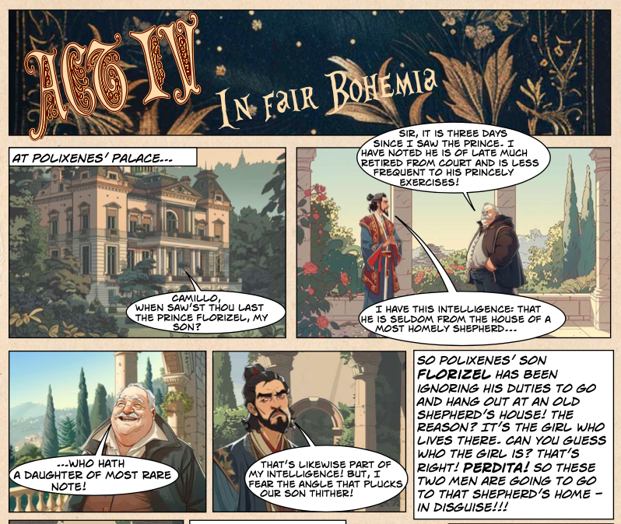
- Who is Florizel?

The son of Hermione The son of Polixenes

The son of Camillo The son of Leontes

- Where has Florizel been spending his time?

At school Horseriding

At the shepherd’s house Swimming in the sea

- Why do Camillo and Polixenes think Florizel has been spending so much time there?

_______________________________________________________

_______________________________________________________

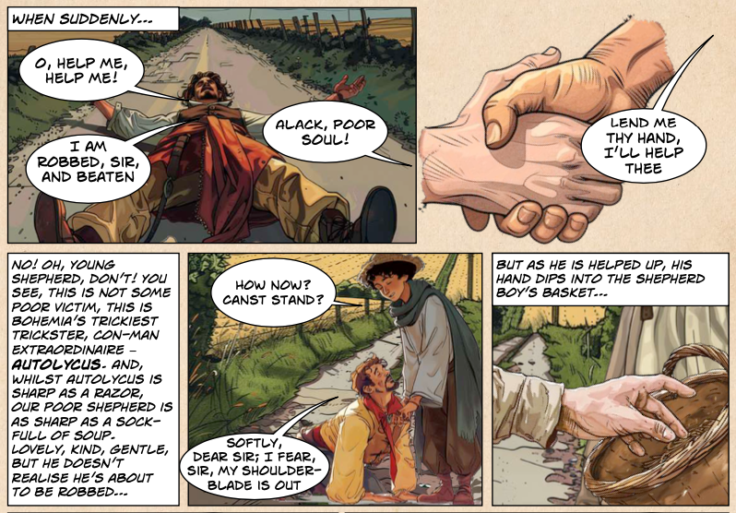
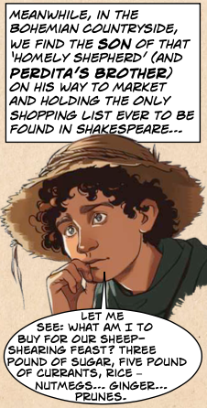
4.Write down three things on Perdita’s brother’s shopping list?

i.__________________________

ii__________________________

iii__________________________

5.What is the name of the “trickster” who robs Perdita’s brother?

__________________________________

6. What synonym for “trickster” does the author also use?

__________________________________

7. What similes does the author use to describe

- Autolycus: as _________________________________________

- The poor shepherd: as __________________________________

8. Write down two words used to describe the “poor shepherd boy”

i.__________________________

ii__________________________
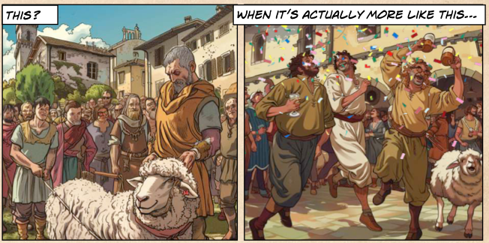

9. Look at the two contrasting pictures above

- Write 2 things which are the same/similar

i.__________________________

ii__________________________

- Write 2 things that are DIFFERENT

i.__________________________

ii__________________________

- Which scene would you rather be in and why?

_______________________________________________________

_______________________________________________________

_______________________________________________________

_______________________________________________________

_______________________________________________________

_______________________________________________________

_______________________________________________________
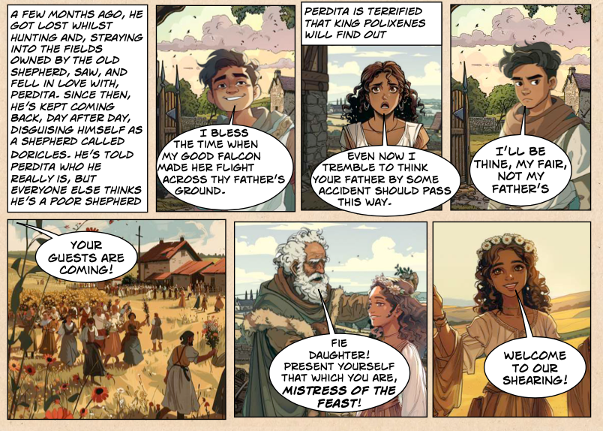

10. How did Florizel first meet Perdita?

_______________________________________________________

_______________________________________________________

_______________________________________________________

11. What has he told everybody his name is?

Pericles Autolycus

Leontes Doricles

12. Who do people think Florizel is?

_______________________________________________________

13. Why is Perdita “terrified”? Use a direct quote from the text

_______________________________________________________

_______________________________________________________
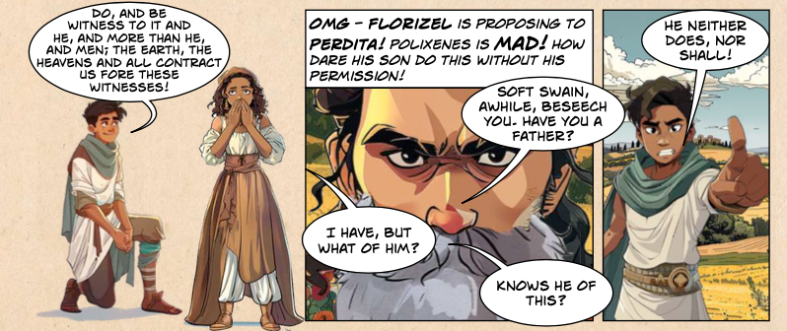

14. What does Florizel do at the sheep shearing festival?

_______________________________________________________

15. Why is Polixenes mad?

_______________________________________________________
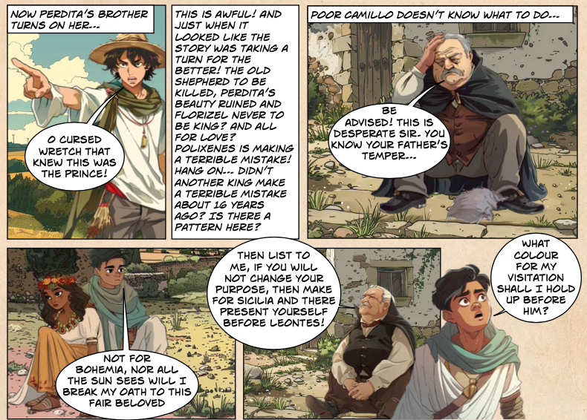

16. Where does Camillo suggest Florizel and Perdita go?

To ask for Polixenes’ forgiveness To Sicilia

To the church To the Oracle
THE WINTER’S TALE
ACT 4
ANSWERS
- Who is Florizel?
The son of Polixenes

- Where has Florizel been spending his time?
At the shepherd’s house

- Why do Camillo and Polixenes think Florizel has been spending so much time there?
Because he’s in love with a girl

4.Write down three things on Perdita’s brother’s shopping list?
Sugar/Ginger/Currants/Rice/Nutmeg/Prunes

5.What is the name of the “trickster” who robs Perdita’s brother?
Autolycus

6. What synonym for “trickster” does the author also use?
Conman

7. What similes does the author use to describe
- Autolycus: as sharp as a razor
- The poor shepherd: as sharp as a sock
8. Write down two words used to describe the “poor shepherd boy”
Kind/lovely/gentle

9. Look at the two contrasting pictures above
A.Write 2 things which are the same/similar
People/Buildings/Sheep

B.Write 2 things that are DIFFERENT
People are dancing/drinking/laughing/smiling/there’s confetti in the air

C.Which scene would you rather be in and why?
Dependant on children- some may say the first picture as it looks calmer/quieter/more organised! Others may say the second picture because it looks more lively/fun

10. How did Florizel first meet Perdita?
He was lost whilst hunting and strayed into one offields owned by the shepherds
11. What has he told everybody his name is?
Doricles
12. Who do people think Florizel is?
A poor shepherd boy
13. Why is Perdita “terrified”? Use a direct quote from the text
Because she knows the truth-that Florizel is a prince and is worried that his father will fin d out that they’re in love!
14. What does Florizel do at the sheep shearing festival?
Propose to Perdita/Ask Perdita to marry him!
15. Why is Polixenes mad?
Because Florizel didn’t ask his permission!
16. Where does Camillo suggest Florizel and Perdita go?
To Sicilia

