Lesson 2 (Drama lesson: debate)

LI: To develop ideas for a discussion text through debate.
National Curriculum Links

Reading
Pupils should be taught to:
- participate in discussion about both books that are read to them and those they can read for themselves, taking turns and listening to what others say.

Spoken Language
- articulate and justify answers, arguments and opinions
- participate in discussions, presentations, performances, roleplay/improvisations and debates

Starter: Freeze Frames
Ask children to think about the way Juliet has changed between Act 1 and Act 3.

First discuss how Juliet reacts when her mother asks her if she could be in a relationship with Paris in Act 1. Children then work in groups to create a freeze frame of this moment with one child playing Lord Capulet, one child playing Lady Capulet and one child playing Juliet. Encourage the children to use powerful facial expressions, strong body language and different levels to make their freeze frame interesting.

Then ask the children to consider how Juliet reacts when she is told she is going to marry Paris in Act 3. Children work in the same groups to create a freeze frame of this moment.

Children switch back and forth between the two freeze frames and discuss how Juliet has changed between these 2 acts.

Main Teaching:
Make sure you are in a large space so the children can spread out in this lesson.

The Question

Explain to the children that they are going to be taking part in a debate in today’s lesson to discuss the following question:

Should Juliet obey her parents?

Ask the following questions to make sure the children understand the issue:
- What do Juliet’s parents want her to do?
- Why does she not want to obey them?

Preparing for the Debate

Split the children into mixed ability pairs and ask them to find a space in the room. Each partner will need something to write on and with.

Explain to the children that they are either going to be on the FOR team or the AGAINST team. Allocate each partner to be on either team, making sure that there are an equal number of pairs on both sides. Make it clear which side each partner is on by giving green paper to the FOR pairs and orange paper to the AGAINST pairs.

Pairs who are part of the FOR team then need to think of reasons why Juliet SHOULD listen to her parents.

Pairs on the AGAINST team need to think of the reasons why Juliet SHOULD NOT listen to her parents.

Give the children some time to think of the reasons why Juliet should or shouldn’t listen to her parents. They then find another pair on the same team. They share their ideas and decide which ideas are the strongest.

Repeat this process: each group of 4 now finds another group of 4 from the same team. Share ideas and decide on the best arguments.
These groups of 8 now find another group from their team. To help facilitate the discussion between this larger group of children, the teacher should lead the discussion between one team and another adult should lead the other team’s discussion (in a different room if possible).

With help from the adult with their group, each team should now pick their strongest 3 arguments.

In each group, decide on 3 children who are going to argue the three points their group has decided are the strongest (one point each). Give each speaker 5 minutes to rehearse their speech while the rest of the class get into position for the debate.

Structure of the Debate

Set up the hall ready for the debate. Here is a suggested set up (from Twinkl):

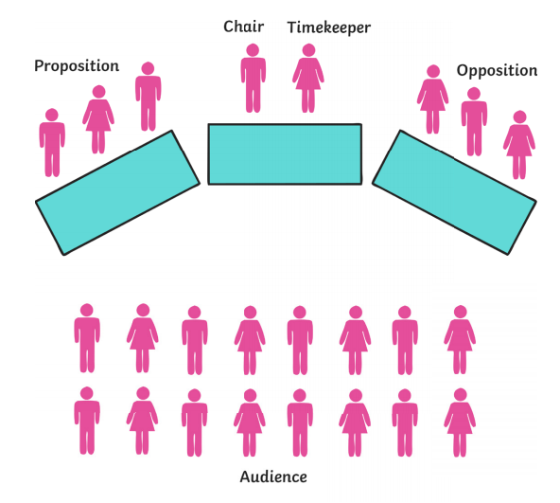

N.B. The teacher should be the chairman who introduces the debate and keeps things moving. A timekeeper can make sure that no-one’s speeches are longer than 3 minutes.

Follow the following structure for your debate:

- The Opening Address – the chairman reads out the motion (‘Should Juliet obey her parents?’) and reminds the audience that they will have a chance to vote at the end of the debate.

- FOR Speaker 1 – gives the first point for the For team’s argument (no more than 3 minutes).

- FOR Speaker 2 – gives the second point for the For team’s argument (no more than 3 minutes).

- FOR Speaker 3 – gives the third point for the For team’s argument (no more than 3 minutes).

- AGAINST Speaker 1 – gives the first point for the Against team’s argument (no more than 3 minutes).

- AGAINST Speaker 2 – gives the second point for the Against team’s argument (no more than 3 minutes).

- AGAINST Speaker 3 – gives the third point for the Against team’s argument (no more than 3 minutes).

- Open to the floor – the chairman declares that the debate is ‘open to the floor’. Now anyone in the audience can raise their hand to share their arguments either for or against the motion.

- Summaries – the chair gives a brief summary of the key arguments on both sides.

- Voting – the audience now votes either for or against the motion (they can change sides from their original team).

Throughout the debate, ask an additional adult to record the key ideas on a flipchart under the headings ‘for’ and ‘against’. This should be on display in the classroom throughout the rest of the week.

