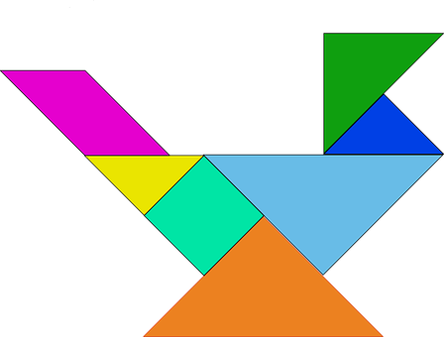
Act 2, Scene 2 – A bird is used as a metaphor at the end of the scene. Cut the tangram into pieces, shuffle the pieces up and try to rebuild the bird.

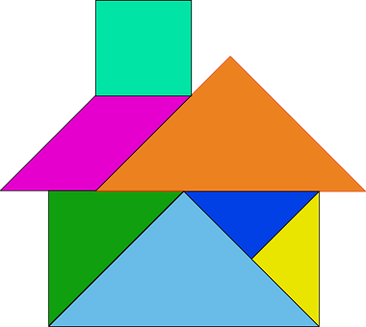
If you were able to solve the bird tangram, try this one of the Capulet Property.

