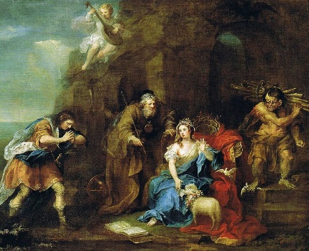
What’s a Name Worth?
a = 124
b = 302
c = 198
d = 234
e = 119
f = 456
g = 237
h = 789
i = 104
j = 247
k = 309
l = 501
m = 992
n = 366
o = 505
p = 405
q = 113
r = 738
s = 325
t = 209
u = 546
v = 384
w = 710
x = 382
y = 254
z = 315

Add all of the letters in each name together to work out whose name is worth the most!

Miranda - The daughter of Prospero
Caliban - Another of Prospero’s servants
Alonso - King of Naples and father of Ferdinand
Ferdinand - Son and heir of Alonso
Prospero - The play’s protagonist, and father of Miranda. Former duke of Milan.
P = 405
r = 738
o = 505
s = 325
p = 405
e = 119
r = 738
o = 505
1243

Sebastian - Alonso’s brother
Antonio - Prospero’s brother
Ariel - Prospero’s spirit helper

Whose name is worth the most?
Whose is name is worth the least?
Now, have a go at finding out what your name is worth. Then chose a friend’s name and work out what theirs is worth. Whose name is worth more?

